
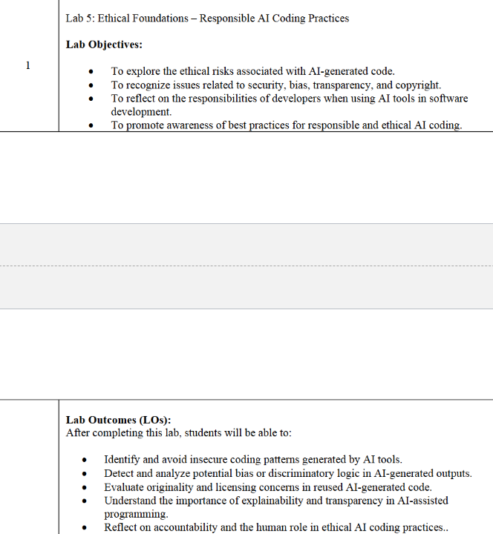
Task Description #1:
• Prompt GitHub Copilot to generate a Python script that collects user data (e.g., name, age,
email). Then, ask Copilot to add comments on how to anonymize or protect this data.
Expected Output #1:
• A script with inline Copilot-suggested code and comments explaining how to safeguard or
anonymize user information (e.g., hashing emails, not storing data unencrypted)
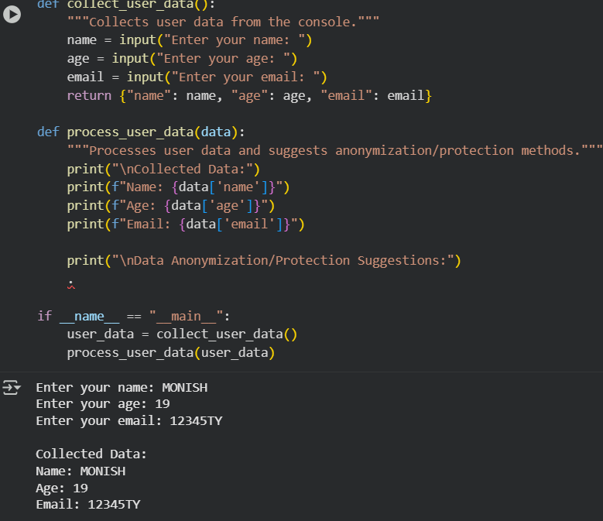
Task Description #2:
• Ask Copilot to generate a Python function for sentiment analysis. Then prompt Copilot to
identify and handle potential biases in the data.
Expected Output #2:
• Copilot-generated code with additions or comments addressing bias mitigation strategies (e.g.,
balancing dataset, removing offensive terms).
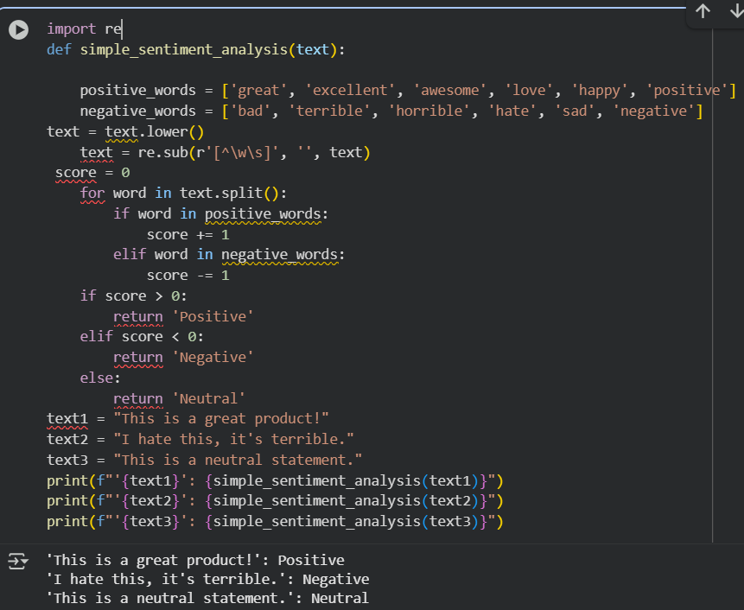
Task Description #3:
• Use Copilot to write a Python program that recommends products based on user history. Ask
it to follow ethical guidelines like transparency and fairness.
Expected Output #3:
• Copilot suggestions that include explanations, fairness checks (e.g., avoiding favoritism), and
user feedback options in the code
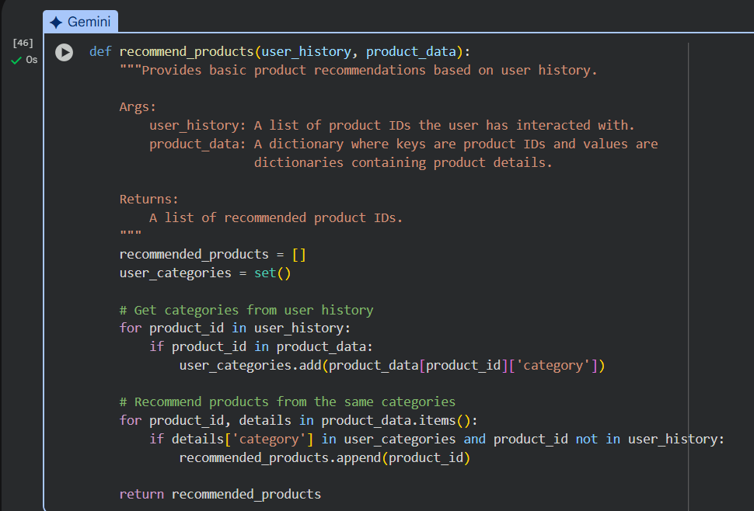
ask Description #4:
• Prompt Copilot to generate logging functionality in a Python web application. Then, ask it to
ensure the logs do not record sensitive information.
Expected Output #4:
• Logging code that avoids saving personal identifiers (e.g., passwords, emails), and includes
comments about ethical logging practices
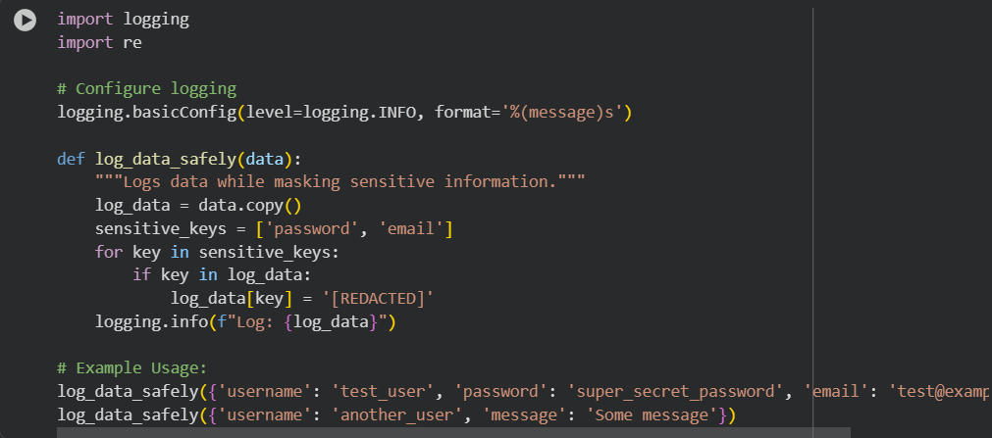
Task Description #5:
• Ask Copilot to generate a machine learning model. Then, prompt it to add documentation on
how to use the model responsibly (e.g., explainability, accuracy limits).
Expected Output #5:
• Copilot-generated model code with a README or inline documentation suggesting
responsible usage, limitations, and fairness considerations
